Sir Joseph Lockwood (1904–1991)

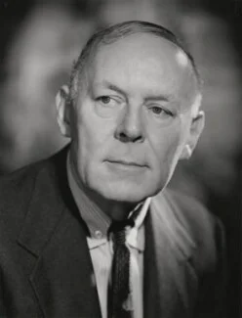
Sir Joseph Flawith Lockwood arrived at EMI in 1954 by what seems, in retrospect, an almost implausible route. Born in Southwell, Nottinghamshire in 1904, the son of a mill owner, he left school at sixteen without qualifications and built his early career on milling machinery, literally writing the book on the subject. When approached and asked to take charge of EMI, the company was losing around half a million pounds a year and was by accounts drifting toward insolvency. Lockwood became chairman on his fiftieth birthday, and the company he left twenty years later was the largest record organisation in the world.
What he did at EMI is well documented and involved big decisions and a huge amount of change. By 1960, annual profits stood at five million pounds. He was knighted the same year.
His instinct throughout was to find audiences that weren't being reached and reach them. Hence Music for Pleasure makes a lot of sense. Chris Ellis, who worked in EMI's cataloguing and production operation during the mid-1960s, interviewed by Mark Berresford:

Then along came our Chairman, Sir Joseph Lockwood, who had recently been to America and had seen the first 'rack job' labels... they put them in anywhere that had room for a rack of 100 LPs. He came back and said we had to have a 'rack job' label, which caused great consternation... the fact we would be selling LPs at half the price of the cheapest record on the market.

Lockwood's idea was received internally with something between scepticism and alarm. However, Music for Pleasure ended up outlasting him by two decades, eventually absorbed into EMI Gold in 1995 and expiring quietly when EMI itself was broken up in 2012.

